For TCAS manual
to log in by using a 13-digit ID number / G-Number or Passport Number or select "Continue with ThaiD"
The system shows the terms and conditions for using the TCASFolio system. Applicants read, understand and select "Acknowledge".

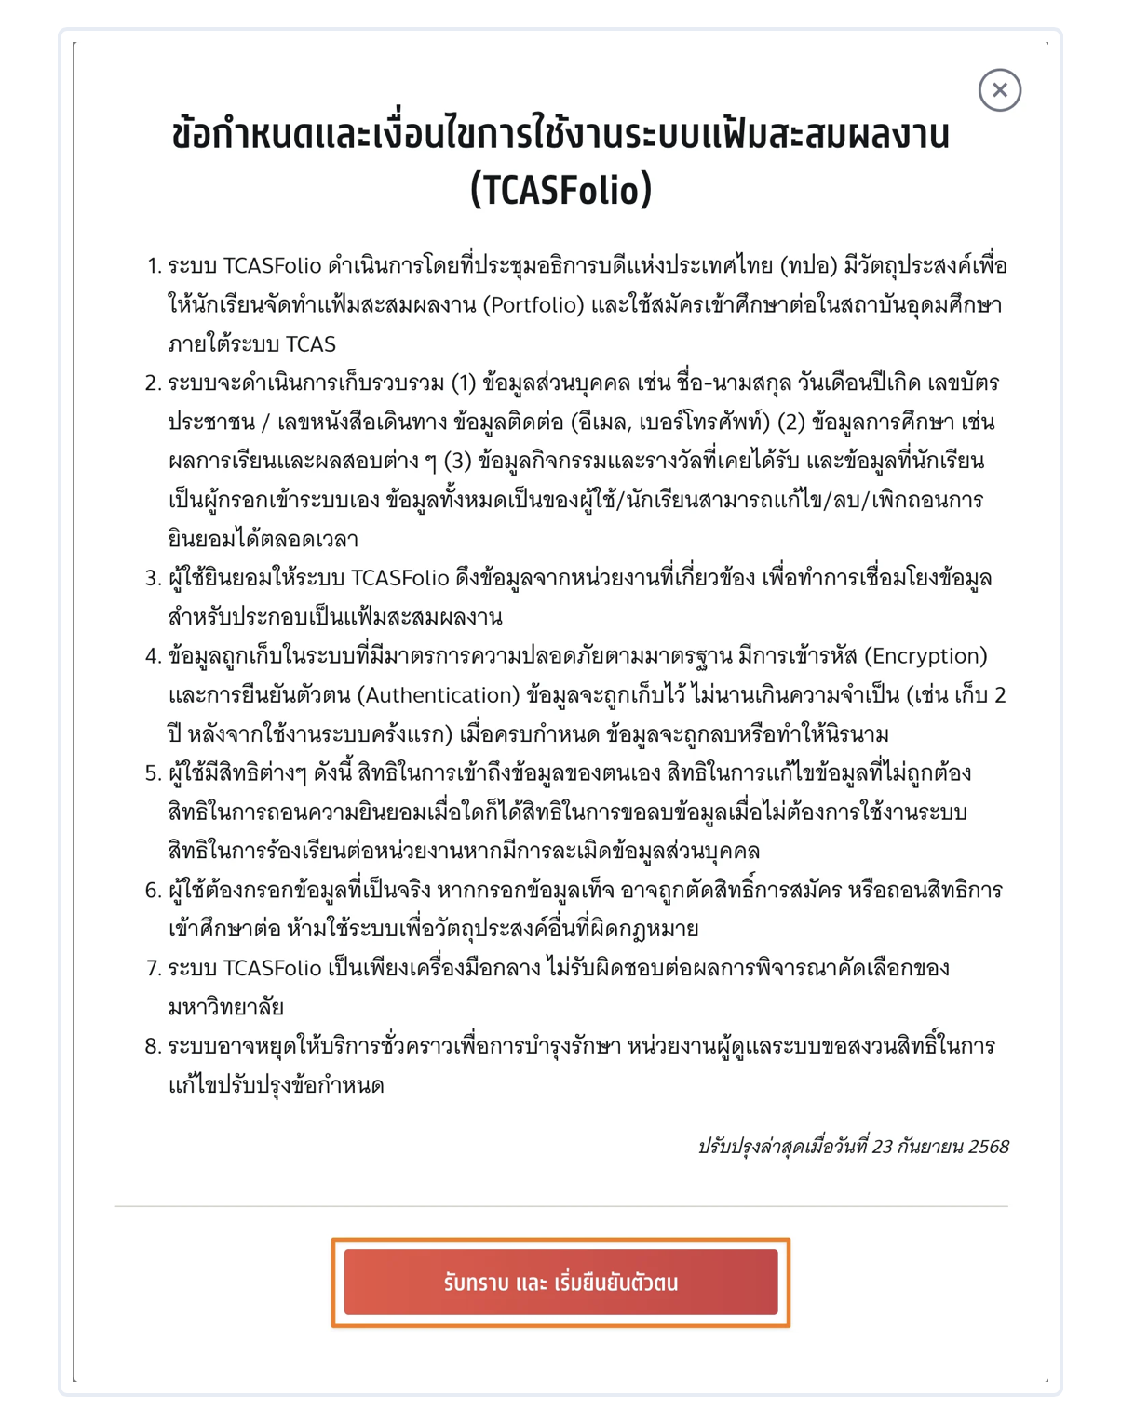

- Specify the email address
- Specify the mobile phone number.
- Choose a prefix
- Specify the name in Thai.
- Specify the surname in Thai language.
- Name in English
- Specify the surname in English.
- Set a password of at least 8 digits consisting of
At least 1 uppercase English letter A - Z
At least 1 lowercase English letter a - z
At least 1 number 0 - 9
Special characters! @#$%^&*()_+|~-=\`{}[]:”;'<>?,. / With or without
- Select "Go to the next page"
- Can connect the login with Facebook or
- Connect the login with Google or
- Log in with password only.
To make it easier to log in next time, applicants can connect to social networks. The selected social network must use the same email that the applicant has filled in the details. Or you can choose to log in with a password only.
Note: For the first time, applicants must fill in the password to register. This information will apply to the TCAS69 system when activated on October 28, 2025.

3. Correction of personal information
After logging in, the system will display personal information. Applicants must complete all the information in the orange frame to be able to create a portfolio.
We will use yellow instead of orange, as long as there is no information in those dedicated sections
4. Linking score information
Score information that is connected to the TCASFolio system. When selecting "Connect Data", the system will display the score with a check mark. To confirm that this score is correct And confirmed by the institution that issued the score
We don’t need it, because ifolio and tcas would be together for us
5. Portfolio creation
Select the "Portfile Portfolio" menu, then select "Create Portfolio".
The system shows that you can choose a major to apply.

Applicants can choose the information they want to show in the portfolio. Both personal information and various score information

After that, fill in the information.
• Essay / Preface / Reason for application
• Certificate
• Project / Project
• Activities
• Certificates / Diplomas / Awards
• Additional questions from the university
When the information is completed, select "Save Portfolio".

6. Downloading PDF portfolio
Once the portfolio has been saved, the applicant can choose to download PDF or copy the link to send it as an internal link to the staff of the institution that applied for download.
I want to add the option of downloading the portfolio in case if the student wants to send it to he parents, or other relatives, but we don’t need link or anything because everything will be saved in the database.

